

**Capture**

**Web Programming 12th Project**

**Submitted to:** Dr Mohamed El Taweel, Eng Amr Dabba

**Made by:**

Ghadeer Hesham 211007423

Zeina Amr 211009812

Farah Magdy 211007566

GitHub Repository:

<https://github.com/ZeinaAmr/WebProgrammingProject>

**ERD:**

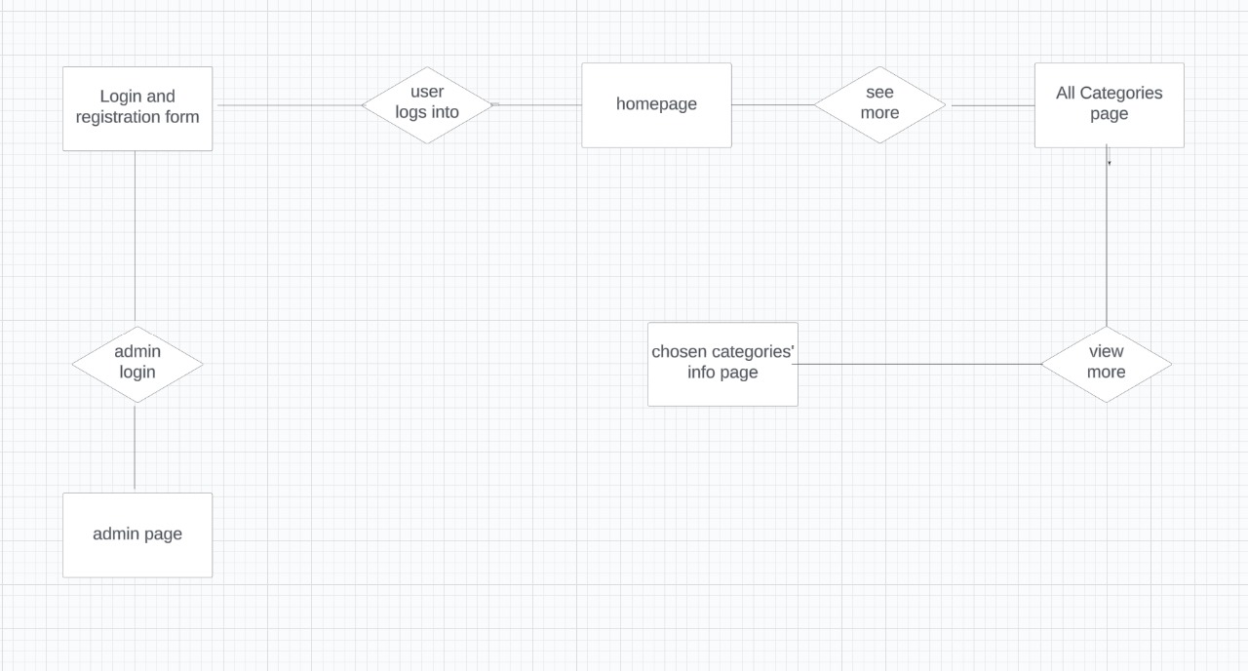

**Purpose of Capture:**

The purpose of Capture is to serve as a digital portfolio and showcase for a photographer's work. It aims to display the photographer's artistic vision, skills, and expertise in capturing captivating and visually appealing images. The specific purposes of Capture can include:

1. Portfolio Display: The website acts as a platform to exhibit the photographer's best work. It showcases a collection of high-quality photographs that highlight the photographer's style, technique, and subject matter expertise. The purpose is to impress potential clients, visitors, and art enthusiasts with a visually stunning display of the photographer's talent.

2. Branding and Identity: The website contributes to building the photographer's brand and establishing a unique identity in the photography industry. It allows the photographer to showcase their signature style, artistic approach, and personal narrative. The purpose is to differentiate themselves from other photographers and create a memorable and recognizable brand.

**Files:**

**Photographers:**

This page allows you to delve into the profiles of Capture's skilled photographers, offering brief insights into their backgrounds and creative journeys. Easily connect with them through their social media links, or seamlessly navigate to their portfolios by clicking the designated button. The photographers are categorised based on their specialised fields, including wedding photography, fashion photography, and more.

**DeannaWilliams.php, AlexTurner.php, DanielReynolds.php, GabrielMartinez.php, AdrianTurner.php:**

Each web page is a portfolio for a photographer showcasing their latest work, socials, background , contact info and a button for booking them.

**book.php:**

This page has a form for clients to fill out to book a photographer. The form has fields for name, address, location, duration, etc. and a calendar for the client to choose a date for booking.

**about:**

This page highlights the distinctive features and attributes that make Capture stand out and contribute to the overall user experience.

**Admin_page.php:**

This web page has different login form than the users and can only be used by admins to access the admin’s dashboard.

**Login-reg.html**

This web page is designed to create a seameless login and registration form for the users. The login form consists of inputs such as: Username and Password. While, the registration form consists of inputs such as: Username, Password, Age,Email.

**Forgot-pass.html:**

This web page is designed to create a seameless Password reset form for the users. It consists of two panels. Each depend on each other. First panel,Enter Email, is to check the user’s email saved in the database and compare it with the input data to check email credibility. Once you click on reset password button, the second panel appears. It’s a form for user’s to fill with their new and confirmed passwords.

**Categories.html:**

The categories page provides a user-friendly interface that allows clients to choose the specific category of photography they want to view. It serves as a navigation hub, organizing the photographer's work into distinct categories or genres to streamline the browsing experience

**Wedding.html, Portrait.html, Wildlife.html, Fashion.html, Architecture.html:**

The photo gallery page dedicated to each category on the photography website is designed to showcase a collection of photographs specifically associated with that particular category. It provides an immersive and visually appealing display of images, allowing clients to explore and appreciate the photographer's work within their desired category.

**Functional Requirements:**

1. User Registration: The website should provide a user registration feature, allowing clients to create an account to access the full functionality of the website.

2. Image Categories: The website should have five categories - wedding, portrait, wildlife, fashion, and architecture - where the client can browse and view images specific to each category.

3. Image Upload: Photographers should be able to upload their images to the website, categorize them under the appropriate category, and provide relevant information about each image, such as the location, date, and description.

4. Photographer Profiles: Each photographer should have a dedicated profile page that displays their portfolio, contact information, and a brief biography.

5. Booking System: The website should include a booking system that allows clients to directly book a photographer for an event or photo shoot. This feature should provide the necessary options for clients to specify their requirements, such as date, time, location, and type of photography.

6. Image Details: Clients should be able to view information about each image, such as the photographer's name and any additional details provided by the photographer.

**Non-Functional Requirements:**

1. Performance: The website should be responsive and provide fast loading times, ensuring a smooth and seamless browsing experience for users.

2. Security: The website should have robust security measures in place to protect user data, prevent unauthorized access, and safeguard against potential cyber threats.

3. Scalability: The website should be designed to handle a large number of images and user interactions without compromising performance. It should be able to scale as the number of users and images grows.

4. User-Friendly Interface: The website should have an intuitive and user-friendly interface, making it easy for clients to navigate through the image categories, search for images, and book photographers.

5. Compatibility: The website should be compatible with different devices and browsers, ensuring that users can access and use the website regardless of their chosen platform.

6. Accessibility: The website should be accessible to users with disabilities, following accessibility guidelines to accommodate individuals with different needs.

7. Backup and Recovery: The website should have regular backup procedures in place to prevent data loss and ensure that the website can be quickly restored in case of any failures or disasters.

**Test Plan:**

1. Introduction:

- Purpose: The purpose of this test plan is to outline the testing approach and activities for the photography website.

- Scope: The test plan covers the functional and non-functional aspects of the website, including user registration, image categories, search functionality, photographer profiles, booking system, and overall performance, security, and usability.

2. Test Objectives:

- To verify that the website functions correctly according to the specified requirements.

- To ensure that the website meets the non-functional requirements, such as performance, security, usability, and compatibility.

- To identify and report any defects or issues in the website's functionality or user experience.

3. Test Environment:

- List the hardware, software, and network configurations required for testing.

- Specify the browsers and devices to be used for compatibility testing.

4. Test Approach:

- Functional Testing: Conduct end-to-end testing of the website's features, including user registration, image categories, photographers profiles, and booking system.

- Non-Functional Testing: Perform performance testing, security testing, usability testing, and compatibility testing.

- Regression Testing: Ensure that new features and bug fixes do not introduce any regressions in the existing functionality.

- Exploratory Testing: Perform ad-hoc testing to identify any unexpected issues or usability concerns.

5. Test Scenarios:

- User Registration:

- Verify that users can successfully create an account and log in.

- Validate that all mandatory fields are correctly validated during registration.

- Ensure that unique usernames and valid email addresses are enforced.

- Image Categories:

- Confirm that images are correctly categorized under the respective categories.

- Validate that the images can be viewed within their respective categories.

- Verify that the correct number of images is displayed in each category.

- Photographer Profiles:

- Verify that each photographer has a dedicated profile page with correct information and portfolio.

- Test the contact information provided on the photographer's profile to ensure it is accurate and functional.

- Booking System:

- Test the booking process, including selecting a photographer, specifying event details, and submitting the booking request.

- Validate that the booking confirmation is received and stored correctly in the system.

- Performance:

- Conduct load testing to determine the website's response time and stability under different user loads.

- Verify that the website can handle a large number of concurrent users without significant performance degradation.

- Security:

- Perform vulnerability scanning and penetration testing to identify potential security weaknesses.

- Validate that user data and sensitive information are handled securely and protected against unauthorized access.

- Usability:

- Evaluate the website's user interface for intuitiveness, ease of navigation, and overall user experience.

- Test the website's responsiveness across different devices and screen sizes.

- Verify that the website meets accessibility guidelines for users with disabilities.

- Compatibility:

- Test the website on different browsers and devices to ensure consistent functionality and appearance.

- Validate that the website is compatible with the specified hardware and software configurations.

6. Test Execution:

- Define the test schedule and allocate resources for testing activities.

- Execute the test scenarios outlined in the previous section.

- Record test results, including any defects or issues encountered.

- Report and prioritize defects based on their severity and impact on the website's functionality and user experience.

7. Test Deliverables:

- Test plan document

- Test cases and test scripts

- Test execution reports

- Defect reports

- Final test summary report

8. Risks and Mitigation:

- Identify potential risks and their impact on the testing activities.

- Develop mitigation strategies to minimize the impact of risks.

- Continuously monitor and update the risk assessment throughout the testing phase.

9. Test Exit Criteria:

- All identified test cases have been executed.

- All high-priority and critical defects have been resolved or appropriately mitigated.

- The test summary report has been reviewed and approved.

10. Test Management:

- Define roles and responsibilities for the testing team members.

- Establish communication channels and reporting mechanisms.

- Monitor and track the progress of testing activities against the defined schedule.